Фрагмент урока по английскому языку в 5 классе
по теме: Family activities
Цели: Повторение и закрепление лексики по теме: «Семья».

Задачи:
Совершенствование лексических навыков по теме: «Семья»;
Совершенствование навыков устной речи;
Воспитание уважения к близким людям
Умение слушать своего собеседника

Оборудование: раздаточный материал, компьютер, экран, проектор, презентация.

Ход урока:

- Начало урока. Организационный момент. Приветствие учеников. Постановка учащимися личностно значимой для них цели.

Teacher: Good morning children!
Pupils: Good morning!
Teacher : I`ve got some pictures for you. Look at the blackboard and try to guess the theme of our lesson.
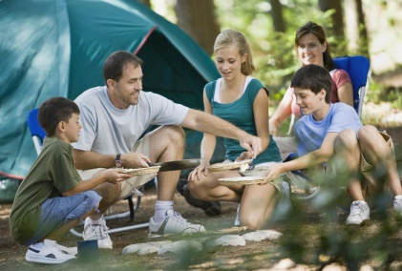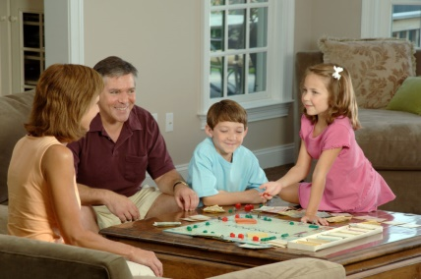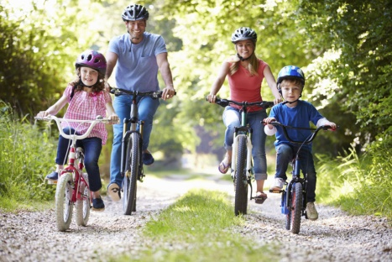

Pupil: I think the theme of our lesson is a family and family activities.
Teacher: Yes, you are right! Today we are going to talk about family time.
- I`d like to know some facts about you and your family.
-The task is easy for you. I will say what I like to do with my family. And if you and your family like the same you should say WE LIKE IT TOO.
-Let`s start!
-We like to ride a bicycle
-And you?
P: WE LIKE IT TOO!
-We like to swim
P: WE LIKE IT TOO!
-We like to go to the park
P: WE LIKE IT TOO!
-We like gardening
P: WE LIKE IT TOO!
-We like to have a good time together
P: WE LIKE IT TOO!
-Excellent job! Thank you!
- I repaired surprise for you and your family.
-Do you like surprises?
P: Yes, we do!
- I'm glad you like surprises!
- Unfortunately, my surprise is closed. I lost the keys.
-Children, will you help me to open the surprise?
P: Yes, we will
-Ok, Let`s have a look. There are 3 tasks for you. I`ll give you the keys if you do the task.
The 1st task is READING

Let`s work in pairs. You should read the text “A great day”. Your task is to choose the answers to the questions. I will give you four minutes.
A great day
It was a great day so Lisa, her father, mother and sister went to the seaside.
Her dad arranged a picnic. They took some sandwiches, cakes and fruit. Lisa always likes her dad’s sandwiches. At fist they wanted to go by train but then they decided to go by car. Lisa’s mother drove a car. When they came to the sea, the weather was fine. There were many people on the beach. Some people lay in the sun, others swam in the sea. Some boys played volleyball. Lisa swam in the sea and her sister rode a pony. Lisa’s parents swam in the sea too. They had a lot of fun. It was a great day!
- Where did Lisa go with her family?
  - She went to a castle.
  - She went to a park.
  - She went to the seaside.
- Who prepared the sandwiches?
  - Lisa prepared the sandwiches.
  - Her mother prepared the sandwiches.
  - Her dad prepared the sandwiches.
- How did they go to the seaside?
  - They went there by car.
  - They went there by train.
  - They went there on foot.
- What did Lisa do there?
  - She rode a pony.
  - She went for a walk.
  - She swam in the sea
(After reading the text the students check the answers and I give the key)
Task № 2
Parents and children enjoy doing things together. Listen to the song “The more we are together” and answer the question “What do children do together?”

The more we are together
The more we are together, together, together.
The more we are together
The happier we are.
For my friend is your friend,
And your friend is my friend.
The more we are together
The happier we are.
The more we sing together, together, together.
The more we sing together
The happier we are.
For his friend is her friend,
And her friend is his friend.
The more we sing together
The happier we are.
The more we dance together, together, together.
The more we dance together
The happier we are.
For our friends are their friends,
And their friends are our friends.
The more we dance together
The happier we are.
The more we dance together
The happier we are.

Let’s sing the song “The more we are together”
(The students answer the question and sing the song.)
I like your singing. Thank you very much.

-I know everybody of you like playing. And now let’s play a bit. Give the opposite meaning of these adjectives.
T-P
unhappy- happy
Shy-brave
Polite- rude
Kind- cruel
Unfriendly- friendly
Independent- dependent
Unlucky- lucky
Non-athletic- athletic
Obedient- naughty

The last task №3
Work in groups. Make a project «My family time»
Imagine that you are family. Try to describe your family and tell about your family activities. You can use the words and pictures for your collage.

