Внеклассное мероприятие в 7 классе по страноведению

«English-speaking countries»
Подготовила учитель английского языка Бабаева Г.Н.
Цели:
Обучающие:
- Закрепление материала по теме «Англо-говорящие страны»;
- Совершенствование навыков чтения, аудирования, монологической речи;
- Совершенствование лингвострановедческой компетенции учащихся.
Развивающие:
- Развитие лингвистической догадки;
2. Развитие интеллектуальных способностей.
Воспитательные:
- Приобщение учащихся к культуре и традициям англо-говорящих стран;
- Воспитание умения работать в команде.

Оборудование:
- мультимедийное оборудование, презентация , видеоклип;
- раздаточный материал для соревнующихся команд;
- грамоты;

Ход мероприятия

- Организационный момент.
T: Good morning, dear children. How are you? Today we will play a game devoted to one interesting topic. And I would like you to see this video file.
Просмотр видеоклипа
What associations do you have with what you have just seen?
What is common with these countries? What language do people in America and Great Britain speak? What do you think about the topic of our lesson?
Today our lesson is devoted to the topic "English-speaking countries". As it is clear from the title we will speak about those countries where the official language is English. And I want to offer you to have a competition. For this competition you should split up into three teams.
Команды рассаживаются за три стола.
Teacher: Please, give the names to your teams. They should be connected with the topic of our lesson "English-Speaking countries". Well, now your teams have names and we can start.

- Основная часть
  - Our first competition is "Shape".
Каждой команде раздаются листы, на которых нарисованы контуры различных англо-говорящих стран: Великобритании, Соединённых Штатов Америки, Австралии, Канады, новой Зеландии. Учащиеся получают задание определить по контуру название страны.
So, I'll give each team these sheets of paper. You can see the shapes of different English-speaking countries there. Guess what countries have such shapes. You have three minutes for this task.

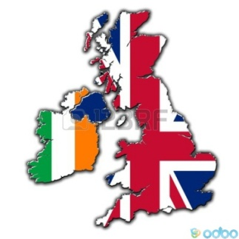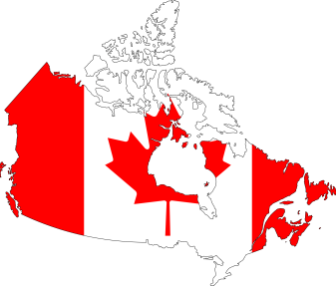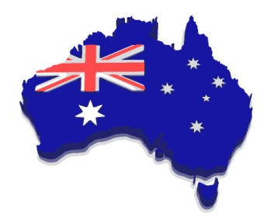

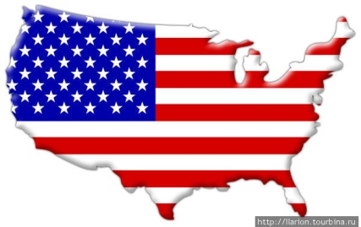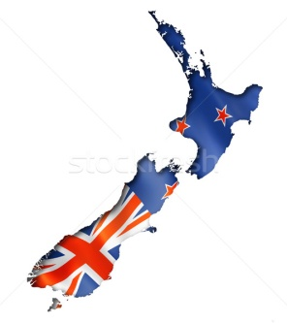

В течение трёх минут учащиеся обсуждают свои ответы.
Teacher: Well. Time is up. Let's check. Please, give your sheets of paper to our teachers.
Учащиеся обеих команд отдают свои работы на проверку учителям из жюри, учителя проверяют ответы и оглашают баллы.
Teacher: Well, let's name all English-speaking countries once more.
Pupils: The United Kingdom of Great Britain and Northern Ireland, the United States of America, Canada, Australia, New Zealand.
Teacher: That's right.

II. The next competition is "Stop Game"
Teacher: So, the rules of this game are the following: I read you some texts about English-speaking countries but I don't mention the name of the country. You listen to me very attentively and try to guess this country. If you are ready to answer you can cry: "Stop!" and name the country. If the answer is right you'll have one point. If the answer is wrong I continue my reading. The other team has right to answer. The team that will guess more countries wins. Are the rules of the game clear? Let's begin then.
Второе соревнование заключается в том, что учитель читает текст о стране, команды если они знают ответ, останавливают учителя называют страну, если их ответ неверный учитель продолжает читать и другие команды имеют шанс заработать баллы.
Texts for reading
1) This country is situated in the central part of the North American continent. It is one of the most powerful and advanced countries in the world. New York is the financial and cultural center of the country. It has the third largest population in the world. It's a real melting pot. It is washed by two oceans: the Pacific Ocean and the Atlantic Ocean. It is the fourth largest nation in the world. The head of the state is President. (The USA)

2) This country is situated on a group of islands lying in the north-west part of the continent of Europe. There are no high mountains, no very long river, and no great forest in this country. The population of the country is almost fifty-six million. It is a capitalist's country. The head of the state is the Queen. This country consists of four parts. (The United Kingdom of Great Britain)

3) This country is the second largest country in the world. It shares with the USA seven of the world's largest lakes and also has three of the world's longest rivers. The maple leaf is the official emblem of the country. There are two official languages in the country, English and French. (Canada)

4) It is a small and quit country in the Pacific Ocean. It consists of two main islands and some smaller islands. It looks like Italy upside down. When it's summer in Europe, it's winter in the country. When it's time to go to bed in Europe, it's time to go to work in this country.
The population of the country is mixed. The official languages are English and Maori. New Zealand is sometimes called "The World's Biggest Farm". It is famous for its products: butter, cheese, meat. (New Zeeland)

5) It is the biggest island and the smallest continent in the world. It is the only country in the world which occupies a whole continent and some islands around it. It's a large country, but it's population is only 18.3 million people.. Sometimes this country is called "Oz" or "the Lucky Country". You can meet amazing animals in this country such as panda, kangaroo and many others. (Australia)

III. The next competition is called "Quiz"
Teacher: Well, the rules of the quiz are the following. Each team should answer the questions.
I read you a question and if you know the answer, you put up your hand and give your answer. If their answer is wrong the other team may answer the same question. Are the rules clear?
В следующем задание команды должны дать как можно больше правильных ответов на вопросы, жюри подсчитывает количество правильных ответов.

Questions
1. What is the capital of the United Kingdom? (London)
2. What is the capital of Australia? (Canberra)
3. What is the capital of New Zealand? (Wellington)
4. What is the capital of the USA? (Washington)
5. What is the capital of Canada? (Ottawa)
6. What is the UK called? (an island state)
7. What is the USA called? (a real melting pot)
8. What is Canada called? (the second largest country in the world)
9. What is Australia called? (a" Lucky Country")
10.What is New Zealand called? (the World's Biggest Farm, Italy upside down)

1. What is the name of the London residence of Queen Elizabeth II? (Buckingham Palace)
2. Who is the architect of the of the famous St. Paul"s Cathedral? (Sir Christopher Wren)
3. What is the nickname of London"s Underground? (the Tube)
4. Where can you see wax figures of many famous people? (in Madame Tussaud"s)
5. What is the largest museum in London? (the British Museum)
6. Who was the first woman Prime Minister in the UK? (Margaret Thatcher)
7. What is the name of the first Queen of the United Kingdom? (Victoria)
8. What is the traditional male costume in Scotland? (the kilt)
9. Who discovered America? (Christopher Columbus)
10. Who was the first president of the USA? (George Washington)
11. Where is the Statue of Liberty situated? (in New York)
12. How many stripes does the American flag have? (thirteen)
13. What is the national sport in America? (baseball)
14. In which month is Thanksgiving Day celebrated? (November)
15. What is the official language of Australia? (English)

1. Назовите самые большие часы и мире. («Биг Бен»)
2. Какой праздник отмечают в Великобритании 31 октября? (Хэллоуин)
3. Какой театр основал Шекспир и другие актеры? («Глобус»)
4. Кому установлен памятник в центре Трафальгарской площади? (адмиралу Нельсону)
5. Назовите самый широко распространенный музыкальный инструмент в Шотландии (волынка)
6. Назовите предместье Лондона, где ежегодно проводятся соревнования по теннису. (Уимблдон)
7. В каком городе расположен Голливуд? (в Лос-Анджелесе)
8. Какая самая длинная река в Америке? (Миссисипи)
9. Назовите самый большой город в США. (Нью-Йорк)
10. Какая страна подарила Америке статую Свободы? (Франция)
11. Назовите национальную эмблему Новой Зеландии. (Птичка киви)
12. Назовите национальный символ Канады. (Кленовый лист)

IV. And now let’s practice in English.. Please one member of your team must go to the blackboard and try to read tongue-twister. You must read it as quickly as you can.
Один из участников команд выходит к доске выбирает случайным образом скороговорку и пытается ее прочитать учителя оценивают участников.
Скороговорки
[u:], [w], [tʃ]
How much wood could a woodchuck chuck
if a wooodchuck could chuck wood?
A woodchuck could chuck as much wood
as a woodchuck would chuck
if a woodchuck could chuck wood.

[b], [e]
How many berries could a bare berry carry,
if a bare berry could carry berries?
Well they can’t carry berries
(which could make you very wary)
but a bare berry carried is more scary!

[u], [k], [g]
How many cookies could a good cook cook
If a good cook could cook cookies?
A good cook could cook as much cookies
As a good cook who could cook cookies.

V. The next task match the countries and the capitals (соедините страны и столицы)
The UK London
The USA Washington
Australia Canberra
New Zealand Wellington
Canada Ottawa

VI. The next task find rhyming words.Найти рифмующиеся слова. Вам даётся 2 минуты. (Учащиеся составляют список рифмующихся слов и отдают жюри на проверку.)
Cat  Plate  Car  Floor  Book  Lamp  House  Our  Pen  Bag  Light  Day  Tree  Chalk  Name  Feet  Foot  Face  Spoon  Fork  Box  Sand  Stick  Street  Fish | fat  gate  far  door  look  camp  mouse  flower  men  flag  night  pay  three  walk  game  treat  boot  trace  moon  dock  fox  hand  pick  meet  dish

VII. Do you like to do puzzles? Let’s find out how clever you are! Вы любите отгадывать загадки? Давайте посмотрим, сколько загадок на английском языке вы сможете разгадать. Загадки задаются по очереди каждой команде, если команда не знает ответа, ход передается следующей. (Ответы учащиеся передают жюри.).
Riddles:
1. It runs but has no legs.
2. It’s black when it’s clean.
3. What goes up when the rain comes down?
4. Children don’t like to drink especially when it’s warm.
5. It is white. It is cold. We can skate on it. What is it
6. What man cannot live inside the house?
7. A little old woman with twelve children
8. Some short, some long, some cold, some hot. What is she?
9. Who is the most famous woman-writer of detective stories?
VIII. Do you know English proverbs? Let’s see how do you know them? Какие пословицы на английском языке вы знаете? Соедините пословицы с их русскими эквивалентами. Match English proverbs with their Russian equivalents. (Приложение 3.)

1. East or West, home is best.  2. Better a lean peace than a fat victory.  3. Business before pleasure.  4. Tastes differ.  5. Every bird likes its own nest.  6. Friend in need is a friend indeed.  7. So many men, so many minds. | a. Худой мир – лучше доброй войны.  b. Сделал дело – гуляй смело.  c. О вкусах не спорят.  d. Всяк кулик свое болото хвалит  e. Друзья познаются в беде.  f. В гостях хорошо, а дома лучше  g. Сколько голов – столько умов

Заключительная часть.
Teacher: Well done. You know a lot about English-speaking countries. But let's see who the winner in our competition is. Who has more points?
Учитель вместе с учениками подсчитывает результаты соревнования и объявляет победившую команду.
Teacher: Well, thank you for the lesson. Bye!

ответы
Задание 2. Rhyme-time: найти рифмующееся слово.
Cat – fat
Plate – gate
Car – far
Floor – door
Book –look – took
Lamp –camp
House – mouse
Our – flower
Pen ––men
Bag – flag
Light – night
Day – pay
Tree – three
Chalk – walk
Name – game
Letter – matter
Feet – treat
Foot – boot
Face – lace
Spoon – moon
Fork – dock
Box – fox

Sand – hand
Stick – pick
Street – meet
Fish - dish

Задание 3. Загадки.
1. It runs but has no legs. (time)
2. It’s black when it’s clean. (a board)
3. What goes up when the rain comes down? (an umbrella)
4. Children don’t like to drink especially when it’s warm. (milk)
5. It is white. It is cold. We can skate on it. What is it (ice)
6. What man cannot live inside the house? (a snowman)
7. A little old woman with twelve children
8. Some short, some long, some cold, some hot. What is she? (a year)
9. Agatha Christy.
Задание 4. Пословицы.
1 – F 2 – А 3 – B 4 – C 5 – D 6 – E 7 – G

