Aa  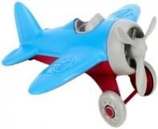  airplane | Bb  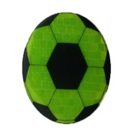  ball | Cc  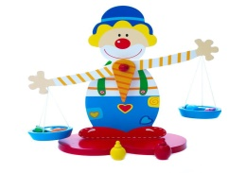  clown | Dd  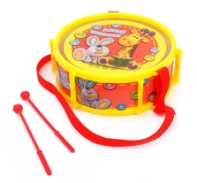  drum | Ee  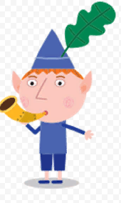  elf | Ff  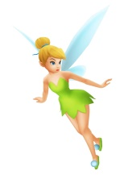  fairy | Gg  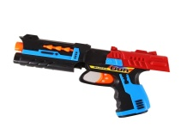gun
Hh  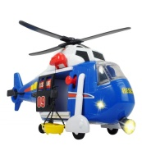  helicopter | Ii    iceboat | Jj  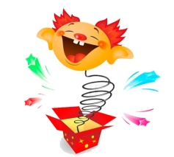Jack-in-the-box | Kk   kite | Ll  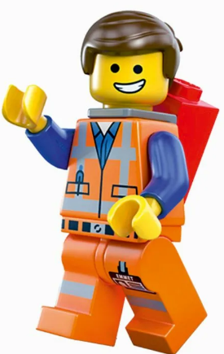  Lego | Mm  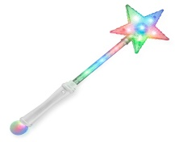  magic wand | Nn  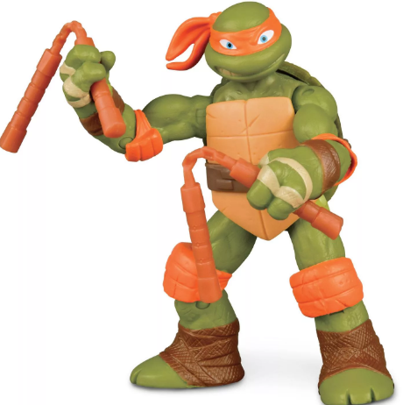  ninja
Oo  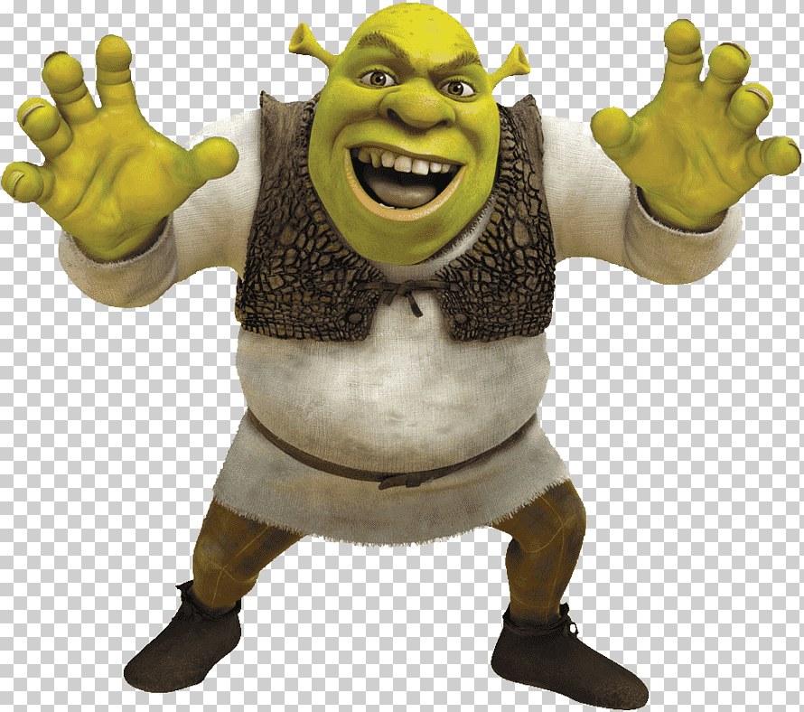  orbital ball | Pp    puzzle | Qq  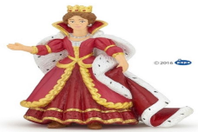  queen | Rr  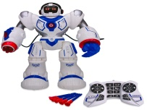  robot | Ss  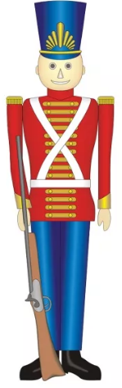  soldier | Tt  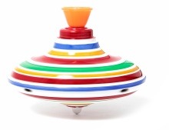  \ top | Uu    unicorn
Vv    van | Ww  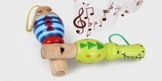  whistle | Xx  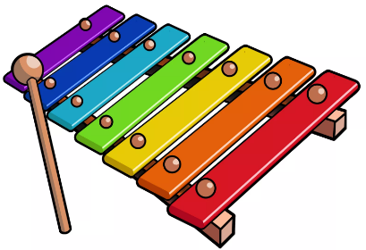  xylophone | Yy  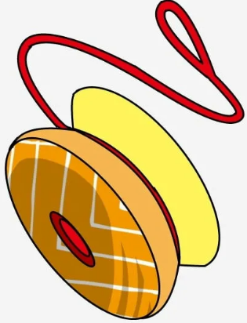  yo-yo | Zz    zombie | 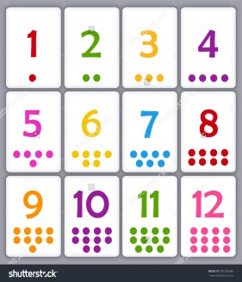 | 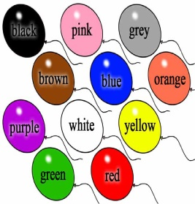
TOY ALPHABET
Aa
One, two, three, four, five.
I am flying in the sky.
I am a little airplane.
My name starts with «A»!

Bb
My ball is blue,
My ball is red,
It jumps and hops all day
And bounces against the wall
And doesn’t want
To stop at all.

Cc
Look, it is a clown.
Orange, green and brown.
Purple, red and blue.
And a yellow too.

Dd
My drum is round,
My drum is big,
My drum is loud,
And it can sing.
Ee
A little elf,
Sat on a tree.
Painting leaves,
To throw at me.

Ff
Fairies are small,
Fairies are nice,
Fairies can fly,
Nigh in the sky.

Gg
I have a toy,
It is a gun.
It is for boys,
We play and have a fun.

Hh
Fly, helicopter, fly.
High in the sky.
Up above the house.
Say goodbye to mouse.

Ii
Iceboat is huge and wide.
It swims left and it swims right.
Up and down , up and down,
In the sea all day and night.

Jj
Of all the toys
In my box,
My favorite toy,
Is Jack-in-the-box.

Kk
If I am small,
And light as air,
I’d clime a kite,
And sail up there.

Ll
I have many toys,
White, red and yellow.
But most of all,
I like Lego.

Mm
If I had a magic wand,
You would be long.
You would be short.
You would be as little as a spot.

Nn
Ninja is a turtle.
It is strong and brave,
It has a green body,
And a smart brain.

Oo
Ogre is big.
Ogre likes meat.
He never smiles,
If wants to eat.

Pp
Puzzles big and puzzles small,
Puzzles square, puzzles round,
Puzzles short and puzzles long,
Puzzles cannot play the dog.

Qq
I bought a dress.
As green as a been.
Now I am,
A nice little queen.

Rr
Robot go right, robot go left.
Robot, show me your hand.
First show me right.
And then show me left.

Ss
One, two, three, four, five,
My soldier is brave, soldier is fine.
My soldier can walk, and it can run.
We play together, we have fun.

Tt
Whirl, whirl,
Like a top.
Stand up, sit down,
Make a face and stop.

Uu
I have a magic unicorn.
It has four legs and single horn.
It likes to watch funny cartoons,
And to eat sweet popcorn.

Vv
My van is fast,
Like a horse.
I drive my van.
And cry SOS.

Ww
Whistle, whistle,
Little whistle.
Loud and quiet,
Day and night.

Xx
Din, don, din, don.
Sometimes high,
Sometimes low.
It is a noisy xylophone

Yy
Up and down,
Down and up.
Yo-yo is a toy,
For my little pup.

Zz
Zombie, zombie,
I have a mouse,
Don’t be afraid,
It is in the house.

