Conditional sentences
(grammar material,practice)
Compiled by V.Kiselyova



Conditional sentences I
(Условные предложения I типа)
Состоят из главного предложения и придаточного предложения условия.
Они выражают реальные условия,относящиеся к настоящему или будущему
времени.
Схемы условных предложений I типа

If … V1(-S) … … will V1 ... … . 1)
Придаточное услов. Главное
If I have time I will visit an exhibition.
(Pr.Simple) (Future Simple)

... will V(1) … … if … V1(-S) … . 2)
Главное придаточное условия
The children will get good marks if they write the test correctly.
(Future Simple) (Present Simple)

«если» - в условных предложениях (Present Simple)
If
«ли» - в косвенных общих вопросах (Future Simple)

Practice
I Insert the verbs in the correct form.
1. If I … him I will invite him to join us.
a) will see b) see
2. We’ll be late unless we … .
a) will hurry b) hurry
3. If it … fine tomorrow,we’ll go for a picnic.
a) is b) will be
4. If I see him,I … him that book.
a) will give b) give
5. If he … all these apples,he will be ill.
a) eats b) will eat
6. If you … away,I’ll call my brother.
a) will not go b) do not go
7. If he … late,we’ll go without him.
a) will be b) is
8. If he … hard today,can he have a holiday next week?
a) works b) will work
9. If you … this magazine,I’ll bring you another.
a) will not like b) do not like
10. If he … university now,he will be sorry afterwards
a) leaves b) will leave

II 1. I’ll look for your book and if I (find) it I (give) you a ring.
- If you put the ice cubes into very hot water,they (crack).
- If he (win),he (get) 100,000 dollars;if he (come) in second,he (get) 50,ooo.
- If he (want) more money,he (have) to do more work.
- If you (not take) this book to the library tomorrow,you (have) to pay a fine.
- If you (like),I (get) you a job in this company.
- If the weather (be) good,we (go) to the country.
- I (tell) him the whole truth if I (know) it.
- If he (invite) me,I (go) to his party.
- If it (freeze) tonight,the roads (be) very slippery tomorrow.

III 1. We wonder if he (come) home on time.
- They ask if the boy (want) to join us.
- If the weather (be) fine tomorrow,we’ll go for a walk.
- I don’t know if she (come) to the party.
- The mother wants to know if her son (take) part in the concert.
- If it (rain) we (take) umbrellas.
- The teacher wonders if you (make) a report at the next lesson.
- The child (fall) ill if he (go) to bed too late every day.

IV Finish the sentences.
- If I go to the USA this summer,I will visit … .
- If I feel hungry this evening,I will eat … .
- If I have time next weekend,I shall go … .
- If I have to write a story for homework,I will write about … .
- If you come to my home,you will see … .
- If it is cold tomorrow,I will put on … .
- If we finish early today … .
- If I quarrel with my parents … .
- If I lose my keys … .
- If we get too much homework … .
- If my fried gets into trouble … .
- I’ll eat my hat if … .
- We will be very happy if … .
- I will be angry with my friend if … .
- Will you help me if … ?

V Make up sentences.
If I go to …,I’ll see (visit)… .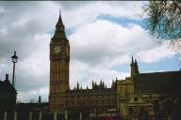

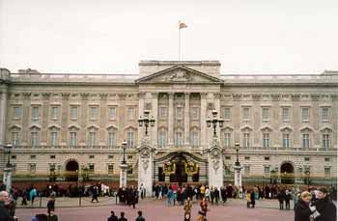
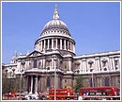


You’ll see …,if you travel (go) to … . 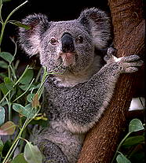 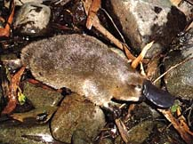 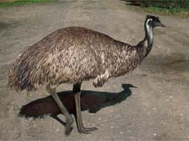
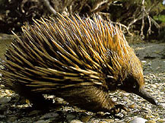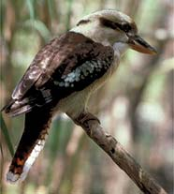
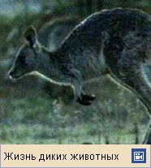

 You’ll see …,if you travel (go) to … .

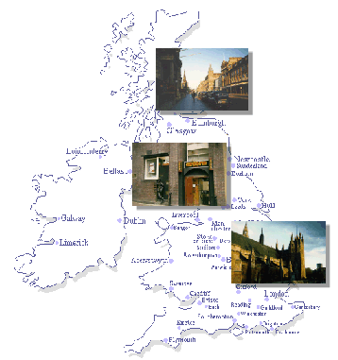
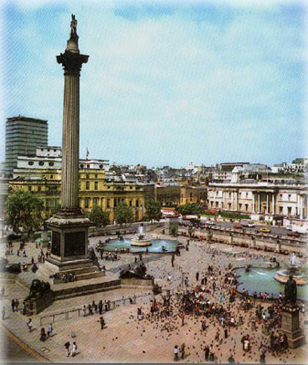

Tests
I 1. If you go to the party you (enjoy) every minute of it.
2. My friend (get) the first place if he (take) part in the competition.
3. Она приготовит очень вкусный обед,если придут друзья.

II 1. I will come home late if I (stay) to make a wall newspaper.
- The students (attend) the lecture if it (be) interesting.
- Если мои родители достанут билеты,они пойдут вечером в
театр.
III 1. If my friend (come) to see me,I will be very glad.
- If mother buys a cake,we (have) a very nice tea party.
- If we (receive) a telegram from him,we (not worry).

IV 1. If you (be) free,I shall come to see you.
- If she knows English,she (try) to enter the university.
- If I (live) in Moscow,I (visit) the Tretyakov Gallery.

V
live in the South go to bed at once
come home late bathe every day
If I receive his letter I will be very sorry
find my book be very glad
lose my money be very happy
see my friend ask his advice

VI 1. If it snows,we … at home.
a) stay b) will stay
2. If she gives him her address,he … her a letter.
a) will write b) writes

VIII 1. We (drink) tea,if we (have no) coffee.
- My friend (go) to the USA,if he (win) the competition.

Poem

Will You Come?
Will you come? Would you come?
Will you come? Would you come
Will you ride If the noon
So late Gave light,
At my side? Not the moon?
O,will you come? Beautiful,would you come?

Will you come? Would you have come?
Will you come Would you have come
If the night Without scorning,
Has a moon Had it been
Full and bright? Still morning?
O,will you come? Beloved,would you have come?

If you come,
Haste and come.
Owls have cried;
It grows dark
To ride.
Beloved,beautiful,come!

Edward Thomas



Conditional sentences II
(Условные предложения II типа)
Выражают маловероятные и нереальные условия,относящиеся к настоящему
или будущему времени.
Схемы условных предложений II типа

1) If … V2 … … would V1 … … .
Придаточное главное

If we visited the Tretyakov Gallery we would see paintings of famous artists.
Придаточное главное

2) … would V1 … … if … V2 … … .
Главное придаточное
They would speak English fluently if they learned the words.
Future-in-the Past Past Simple
Главное придаточное

В придаточных предложениях – was were - для всех лиц и чисел
If I were you I would not make such a mistake.

«если бы» - в условных предложениях (Past Simple)
If
«ли» - в косвенных вопросах (Future-in-the Past)

Practice
Insert the verbs in the correct form.
- If I had a spare ticket,I … take you to the cinema.
a) would b) will
2. John suggested that I should … for another job.
a) look b) have looked
3. If she … you,she would be able to advise you.
a) had been b) were
4. We were afraid lest he should … too early.
a) have come b) come
5. She would buy a new fur coat if her husband … enough money.
a) would give b) gave
6. If the students attended all the lectures,they … their exams successfully.
a) would pass b) passed
7. If I were you I … him.
a) would not forgive b) did not forgive
8. I would help the poor if I … very rich.
a) would be b) were
9. If I were a doctor,I … people healthy.
a) made b) would make
10. They … to the country if the weather were better.
a) would go b) went

II 1. If I (know) his name,I’d give it to you.
- He (look) a lot better if he did more esercise.
- If he worked more carefully,he (not make) so many mistakes.
- I wouldn’t do that if I (be) you.
- More tourists would come to this seaside if it (have) better climate.
- If someone (give) you a submarine,what would you do with it?
- If you (not belong) to a union,you couldn’t get a job.
- If I (win) a big prize in a lottery,I’d give up my job.
- He might get fat if he (go on) eating like that.
- If he knew that it was dangerous,he (not come).

III 1. If you (go) on a diet,you (lose) weight.
- If we (work) all night,we (finish) in time.
- If I see a tiger walking across Hyde Park,I (climb) a tree.
- If you (keep) a cat,the mice (not run) about everywhere.
- If it (be) summer,the people (not sit) round that big fire.
- If you (paint) the walls white,the room (be) much bigger.
- If he (take) any exercise,he (not be) so unhealthy.
- If they (speak) English to her,her English (improve).
- If I (ask) him for help,he (help) me.
- If I (know) his address,I (can) write to him.

IV Finish the sentences.
- If you ate less … .
- If she practiced more … .
- You would look better if … .
- If you came in time … .
- If you didn’t shake the camera so much,your photographs … .
- If I could live anywhere I wanted,I would live … .
- If I had a museum,I would collect … .
- If we were all geniuses … .
- If you came to visit me … .
- I would stand on my head if … .
- I would go to the Canary Isles if … .

V Make “Chains of events”.
1. (Boys) – If I won a car in a lottery … .
2. (Girls) – If I won the title of “Miss Universe” … .

Poem

Quiet Girl

I would liken you
To a night without stars.
Were it not for your eyes.
I would liken you
To a sleep without dreams
Were it not for your songs.

Langston Hughes



Conditional sentences III
(Условные предложения III типа)
Выражают совершенно невыполнимые условия,не реализованные в прошлом.
Схемы условных предложений III типа
1) If … had V3 … … would have V3 … … .
Придаточное главное
(Past Perfect) (Future Perfect)

If you had known grammar better your composition would have been a success.

2) … would have V3 … … if … had V3 … … .
Главное придаточное
The children would have travelled to England if the tickets had been free.

If «если бы»

I Match the parts of the sentences.
1. I would have bought a new coat if a)she would not have waited
2. He would have given her diamonds if for him so long.
3. Her life mighthave been saved if b)everything would have been
4. If he had taken my advice all right.
5. If you have checked the petrol before we started c)only I had had enough
6. If she had not loved him money.
d)he had stolen them from the
museum.
e)the doctors had taken better
care of her.
f)we would not have made so
many stops.
II Insert the verbs in the correct form.
- If I had known that you were in hospital,I … you.
a) would have visited b) had visited
2. If you … ten minutes earlier,you would have got a seat.
a) would have arrived b) had arrived
3. I wouldn’t have believed it if I … it with my own eyes.
a) had not seen b) would not have seen
4. If I … that you were coming,I’d baked a cake.
a) would have known b) had known
5. If I … what a bad driver you were,I wouldn’t have gone with you.
a) had realized b) would have realized
6. If he had known that the river was dangerous,he … to swim across it.
a) would not have tried b) had not tried
7. If you … more slowly,he might have understood you.
a) had spoken b) would have spoken
8. If he had known the whole story,he … so angry.
a) would not have been b) had not been
9. If I … again,I think that I would have succeeded.
a) would have tried b) had tried
10. If I … ready when he called,he would have taken me with him.
a) would have been b) had been

III 1. If there (be) any snow round there,we (go) skiing.
- If my friend (know) my address,he (find) my house.
- If I (receive) your letter,I (answer) it.
- If he (give up) smoking,he (look) better.
- If we ( invite) them,they (come) to our party.
- If I (know) they need me,I (come) at once.
- If we (learn) the truth,she (be) very angry.
- If he (study) more,he (pass) his exam easily.
- If the story hadn’t been true,the newspaper (not print) it.
- We (go) by air if we (have) enough money.

IV Make “Chains of events”.
- If Cinderella hadn’t met a Fairy … … .
- If Prince Gvidon and his mother hadn’t been thrown into the ocean in the
barrel … … .
- If tsar Dadon hadn’t taken the golden cock from the wise old man … … .



Tests
Variant 1
- Choose the right form of the verb.
- What … you … if your car was broken?
A) will … do; B) would … do
b) All the students … the lesson if the teacher explains it again.
A) will understand; B) would understand
c) If you paid more attention to grammar,you … the composition better.
A) will write; B) would write
d) If you found a purse in the street,you … it to the police.
A) will take; B) would take
e) My parents … upset,if I lose my key.
A) will be; B) would be
f) You … a good time if you stayed at a hotel.
A) will have; B) would have
g) We … to the theatre if Peter wasn’t well.
A) would not go; B) would not have gone
h) If the weather were bad,we … out.
A) would not go; B) would not have gone
i) If he had stopped the bus,the accident … .
A) would happen; B) would have happened
j) I would have gone out if my mother … at home.
A) wasn’t; B) had been
k) If I … George,I would have invited him to the party.
A) knew; B) had known
l) If youhad done that,you … all right.
A) would have been; B) would be

- Translate into English.

- Я пришёл бы к вам вчера,если бы вы позвонили мне.
- На вашем месте я попытался бы поехать в 3 часа.



Variant 2
- Choose the right form of the verb.
- What … he … if he won a million dollars?
A) will … do; B) would do
b) If they catch the train,they … in time.
A) will arrive; B) would arrive
c) If you took more exercise,you … better.
A) will feel; B) would feel
d) If it stopped raining,they … shopping.
A) will go; B) would go
e) If I didn’t pass my exam,I … on vacation.
A) will not go; B) would not go
f) I … very angry,if you did not come to my birthday.
A) will feel; B) would feel
g) If I had known it,I … to meet them.
A) would go; B) would have gone
h) If the bloue matched the shirt,she … it.

A) would buy; B) would have bought
i) If you didn’t wear a warm coat,you … cold.
A) would be; B) would have been
j) He would have been late for his job if he … the train.
A) had missed; B) missed
k) If you … that,you would be poisoned.
A) drank; B) had drunk
l) If the weather … warmer they would have enjoyed the picnic.
A) had been; B) was

- Translate into English.
- Я бы ему написал,если бы вчера узнал его адрес.
- Если бы я поехал в Атланту,я бы посетил Музей «Кока-колы».
Ключи к тесту:
Вариант 1 | Вариант 2
Задание 1 | Задание 1
- B d) B g) A j) B  - A e) A h) A k) B  - B f) B i) B l) A | a) B d) B g) B j) A  b) A e) B h) A k) A  C) B f) B i) A l) A
Задание 2 | Задание 2
а) I would have come to you  yesterday,if you had called me.  b) If I were you,I would try to  go at 3 o’clock. | a) I would have written him,if  I had known his address yester-  day.  b) If I went to Atlanta,I would  visit Coca-cola museum.

Short tests (5-10 minutes)
Conditionals II
Put the verbs in the right form.
- If he (not read) so much,he would not be so clever.
- If you were not so careless about your health,you (consult) the doctor.
- My father (have) more free time if he (not read) so many newspapers.

- If she (not be) so absent-minded,she would be a much better student.
- If you were a poet,you (write) beautiful poems.
- If you (ring) me up,I (tell) you a secret.

Conditionals III
- If I had met you yesterday I (tell) you something.
- I (get) a good mark if I had learned my lessons.
- If I (read) this new book I (find) out all about this discovery.

- If she (not help) me,I should have been in a very tough situation.
- He (meet) his friend if he had come to our house yesterday.
- If you (let) me know yesterday,I (bring) you my book.

Open the brackets and write each sentence in the I,II and III types of Conditionals.
- If you (be) free,I (come) to see you.
- If I (see) her,I (be) glad.
- If we (receive) a telegram from him,we (not worry).
- If you (be) busy,I (wait).

Conditionals of the I,II,III types.
Open the brackets and write each sentence in the I,II,III types of Conditionals.
- If you (come) on time,we (catch) the train.
- If the team (win) the match,it (be) a champion.
Make up the sentences.

At home go to bed at once.
If I am a poet I would got that book.
in the South be very sorry.

If I ( were) come home late bathe every day.
gone to the library I will gone to the theatre.
fall ill been pleased.
If I had (been) had a ticket yesterday I would have write nice poems.
met you yesterday have a good time.
lose my money go to the doctor
Translate.
Если погода была бы(будет)хорошая,мы бы играли(будем) играть в футбол.

