Муниципальное автономное общеобразовательное учреждение «Гимназия №1»

муниципального образования «город Бугуруслан»

Мультимедийный урок

английского языка в 7 классе "Человек и окружающий мир",

учебная ситуация

"Загрязнение окружающей среды"



Подготовила:

Учитель английского языка

Высшей квалификационной категории

Тарханова Ю.А.

Бугуруслан, 2019
Данный урок разработан для учащихся 7-го класса в рамках темы “Человек и окружающий мир” (“Man and the Natural World”), учебная ситуация “Загрязнение окружающей среды” (“Pollution”), на основе УМК “Английский язык” для 6 класса школ с углубленным изучением английского языка, лицеев и гимназий, авторов О.В. Афанасьевой, И.В. Михеевой.
Тема урока: “Хрупкая планета” (“The Fragile Planet”).
Тип урока: обобщение и систематизация знаний учащихся по теме урока с мультимедийным сопровождением.
Вид нестандартного урока: конференция.
Цель урока: научить школьников использовать английский язык как инструмент общения в диалоге культур современного мира.
Для достижения цели урока необходимо решить следующие задачи:
1. Образовательные:
- совершенствование умений и навыков аудирования, чтения и говорения;
- обобщение единичных знаний в систему.
2. Воспитательные:
- формирование основных мировоззренческих идей;
- трепетного отношения к окружающему миру;
- развитие навыков группового взаимодействия.
3. Развивающие:
- формирование познавательного интереса учащихся;
- обеспечение общего кругозора и связи изучаемого с явлениями и процессами реального мира.
ХОД УРОКА
I) ОРГАНИЗАЦИОННЫЙ МОМЕНТ.
Teacher: Good afternoon, boys and girls!
Teacher: Entering the classroom you’ve got the cards of different colours. Join the group according to the colour of your card.
Teacher: Today we have an unusual lesson. You are the participants of the Ecological Congress. We have 2 groups. The participants with green cards are environmentalists (учащиеся поднимают карточки). The participants with yellow cards are citizens of cities. We’ll play a game with you at the end of which we’ll see who can save of our planet: only the members of Greenpeace or and just all people together.
II) ЦЕЛЕПОЛАГАНИЕ.
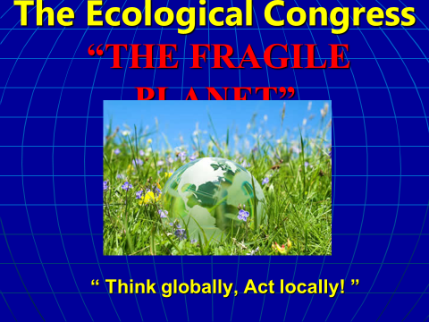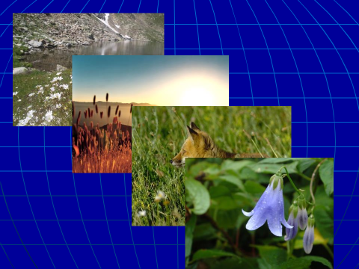
Teacher: The topic of our congress is “The Fragile Planet”. We live on the Earth and everything around us is a part of it. We depend on our planet, on the sun, on animals and plants around us. But now our planet, animals and people are in danger. There are serious ecological problems on our Earth. You are invited to the Congress to exchange your opinions on the global problem how to protect our Earth.
III) СИСТЕМАТИЗАЦИЯ ЗНАНИЙ УЧАЩИХСЯ ПО ТЕМЕ.
1) Актуализация знаний учащихся по изученной лексике.
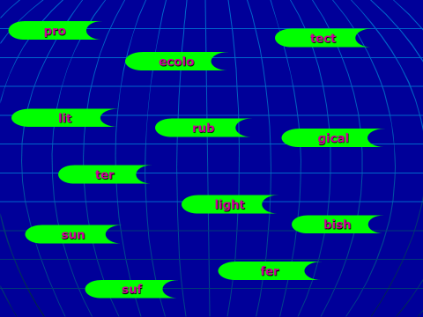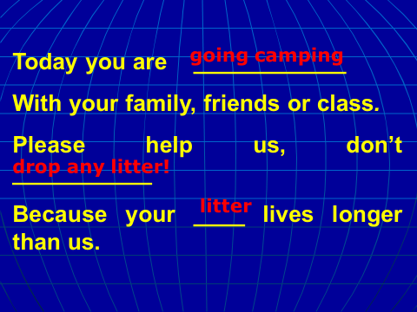
Teacher: Let’s start with the brain storm. Each group should write down the words which are necessary for today’s discussion.
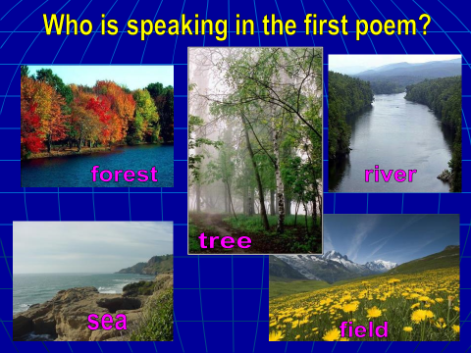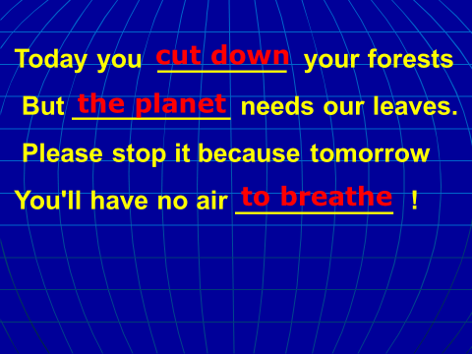
(Учащиеся работают в группах на скорость, кто быстрее составит слова о проблемах экологической ситуации по правилам игры в «Домино», затем они должны зачитать их и перевести).
Pro-tect, ecolo-gical, prob-lems, rub-bish, du-mp, was-te, poi-son, disa-ster, lit-ter, fil-ters, sun-light, suf-fer.
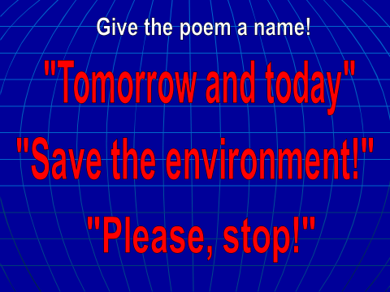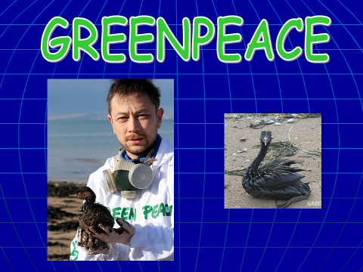
2) Совершенствование навыков монологической речи с наглядной опорой.
Teacher: Look at the screen. Make comments on the song which is shown on the screen.
(Учащиеся получают карточки с пропущенными словами).
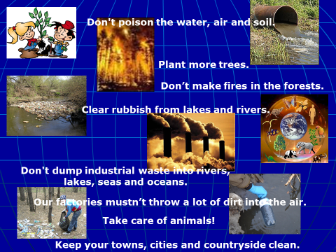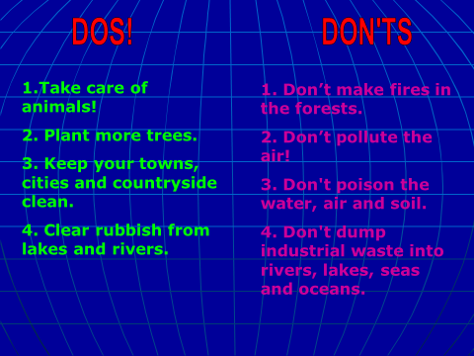
The song
1. Today you are _____ ______
With your family, friends or class.
Please help us, don’t ____ _____ _____
Because your _______lives longer than us.
Key: going camping, drop any litter!, litter
2. Today you ____ _____ _____ your forests
But _____ _____ needs our leaves.
Please stop it because tomorrow
You'll have no air_______!
Key: cut down, the planet, to breathe
3. Because nothing is ________
And _______ is getting tired.
If we don't stop and think today
Tomorrow ______ _______ could die.
Key: forever, nature, the Earth
4. You can have a bath or a _______
But today is the time to think.
Save the _______ because without them
You'll have no water to_______.
Key: shower, rivers, drink
Teacher: Read the poem. Check your answers on the screen.
Teacher: Who is speaking in the first verse? (forests and fields)
Teacher: Who is speaking in the second verse? (trees)
Teacher: Who is speaking in the third verse? (earth)
Teacher: Who is speaking in the fourth verse? (rivers and seas)
Teacher: Will you give the poem a name?
Teacher: Choose the best one: “TOMORROW AND TODAY!”, “SAVE THE ENVIRONMENT!”, “OCEANS, FORESTS AND ANIMALS”, “PLEASE, STOP!”
Teacher: As you see, the ecological problems are dangerous not only for people but also for animals, birds and plants. They need growing space too.
Teacher: Man is beginning to understand that his environment is not just his own town or country, but the whole earth. That’s why people form the organizations that work to protect the environment from harm. Can you name the most famous of them? (Greenpeace)
3) Совершенствование навыков ознакомительного чтения.
Teacher: We have the report about this organization made by 3 reporters. By mistake they divided this report into 3 parts and mixed them. Read the text and put the paragraphs into the right order.
(Учащимся раздаются карточки)
Greenpeace
A Sometimes Greenpeace activity can be quite dangerous. For example, on July 10, 1985, the Greenpeace ship Rainbow Warrior that was on its way to French Polynesia to protest against nuclear tests, was destroyed by French agents. It created a serious international accident.
B Greenpeace is an international environmental organization. It was founded in 1969 by a group of Canadian environmentalists. They block the way to the ships that try to dump waste, and create a nuclear-free world and care about the future of the world.
C Greenpeace has offices in many countries of the world including Russia. Greenpeace members are often referred to as "greens". The "greens" are groups of people whose aim is protection of natural things, plants and animals.
Key: B, A, C.
Teacher: Read the first paragraph.
Teacher: Now the second and the third.
Teacher: Check your answers on the screen. <Слайд 20>
4) Работа над мультфильмом «Большое маленькое море»
Teacher: Look at the screen. Make comments on the video files which are shown on the screen.
Teacher: You will seem the cartoon about one of the most dangerous catastrophe. Your task to make a text from the sentences in the lists below.
Task for the film “This small and large sea!”
- Mary went to the forest to pick some flowers for mother’s birthday.
- The world around us is wonderful.
- She saw very beautiful daisies there.
- People turn the planet into a rubbish dump.
- People must keep their towns, cities and countryside clean.
- Mary liked them and cut down.
- People dump and pour industrial waste into rivers, lakes, seas and oceans.
- The flowers began to cry.
- If people don’t solve ecological problems it will be ecological catastrophe.
- “Why have you cut us”, they asked her.
- People should save water, gas, energy and other natural resources.
- Industrial waste can kill fish and other sea animals.
- She understood that she did wrong things and said “Sorry” to the flowers.
- We must recycle and reuse the litter, the industrial waste.
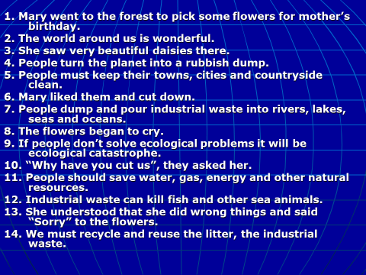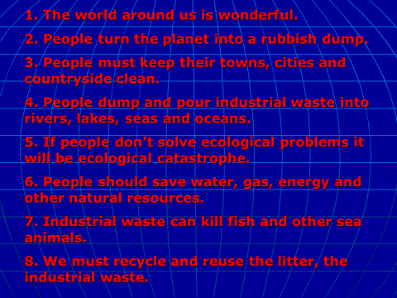
Key: 2, 4, 5, 7, 9, 11, 12, 14.
5) Подведение итогов всей конференции.
Teacher: To sum up our discussion let’s make up the resolution of our Congress. What people should do and mustn’t do to save our planet.
1. Don’t make fires in the forests.
2. Don’t pollute the air!
3. Take care of animals!
4. Plant more trees.
5. Keep your towns, cities and countryside clean.
6. Don't poison the water, air and soil.
7. Clear rubbish from lakes and rivers.
8. Don't dump industrial waste into rivers, lakes, seas and oceans.
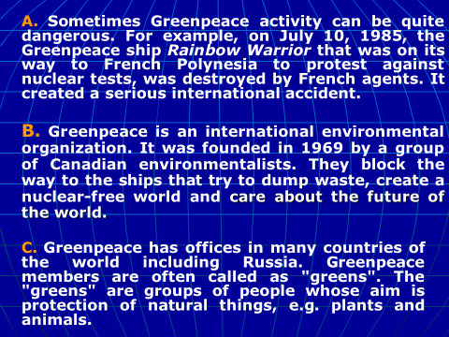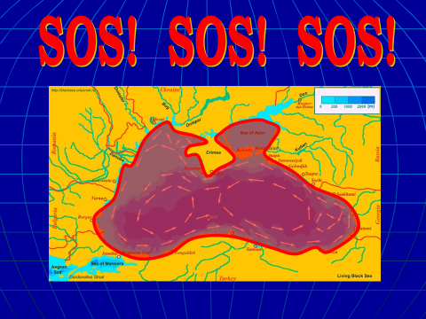
Dos :
1.Take care of animals!
2. Plant more trees.
3. Keep your towns, cities and countryside clean.
4. Clear rubbish from lakes and rivers.
Don'ts
1. Don’t make fires in the forests.
2. Don’t pollute the air!
3. Don't poison the water, air and soil.
4. Don't dump industrial waste into rivers, lakes, seas and oceans.
Teacher: What can you personally do to help the world?
V) ПОДВЕДЕНИЕ ИТОГОВ УРОКА.
Teacher: Our discussion is over. I’m really pleased with you and your work at the lesson. You’ve tried your best and I’ll put you excellent marks.
VI) ИНФОРМАЦИЯ О ДОМАШНЕМ ЗАДАНИИ И ИНСТРУКТАЖ ПО ЕГО ВЫПОЛНЕНИЮ.
Teacher: I’m sure that you are real friends of our fragile planet.
Teacher: The lesson is over.

